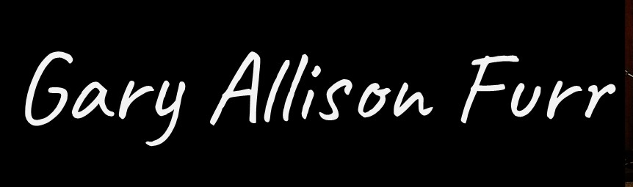

Dr. Gary Furr is a speaker, retreat leader, writer and performing musician.
He recently retired after forty-one years as a pastor. The last twenty-seven years of his ministry he was Pastor of Vestavia Hills Baptist Church in Birmingham, Alabama. Prior to that he served churches in Georgia and Texas. Dr. Furr is a graduate of Carson-Newman University (B. A.) , Southeastern Baptist Seminary (M. Div.) and earned his Ph.D. in theology from Baylor University in Waco, Texas.
Dr. Furr recently completed his fifth album of original songs and has performed widely across the South at universities, churches, corporate events and in music venues. He has been a visiting artist for public schoolchildren in Alabama and New York City and led songwriting groups in Birmingham.
He has served as an adjunct professor at Samford University for many years, teaching both undergraduate students for the Religion Department and at Beeson Divinity School in Spiritual Formation. He has spoken and performed in many different settings through the years, including retreats, conferences and civic events.
He and his wife, Vickie have three grown daughters and enjoy most of all being with their four grandchildren. They continue to make their home in Birmingham and travel as they can.
He has been published widely and edited, written for, and co-authored seventeen books, including Ties That Bind: Life Together in the Baptist Vision, The Dialogue of Worship, For Faith and Friendship, Theology in Service of the Church, and Encountering God in the Prayers of Others as well as numerous journal and magazine articles. He has published Poems, Prayers and Unfinished Promises with Mossy Creek Press.in 2015 and most recently Shadow Prayers: Reflections from a Pandemic Year.

Blog https://garyfurr.me/
Music https://garyallisonfurr.bandcamp.com/
Email me: bhmpicker@gmail.com
Phone: 205-790-4377

